1. Investment goods market

There exists a single type of technology for investment goods. The investment good is offered with infinite supply. The quality of the investment good 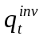 increases over time due to a stochastic process. Every period the quality is increased with probability 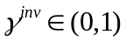 where with probability 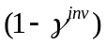 there is no change of quality. In case of an increase the quality of the offered good changes by a fixed percentage 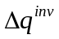 .
The price of the investment good 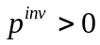 is assumed to be linked to the level of quality, so that a rise of quality leads to a proportional increase of 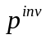. Although capital goods producers are not modelled as active agents the amounts paid for investment goods are channelled back into the economy. Revenues accruing with the investment good producer are distributed in equal shares among all households in order to close the model. Put differently, it is assumed that all households own equal shares of the fictitious capital goods producer.

2. Consumption good producer

2.1 Quantity choice

Every consumption goods producer keeps a stock of its products at every regional mall. For simplicity it is assumed that all producers offer their products in both regions. A producer checks once every period whether any of the stocks it keeps at different malls have to be refilled. To that end the firm receives messages from all the malls it serves reporting the current stock level. Taking this information into account, the firm has to decide whether and on what scale it restocks the supply. According to our approach of using standard managerial methods wherever it is applicable, we employ a standard inventory rule for managing the stock holding. For reasons of simplicity we ignore setup costs that arise for each delivery to a mall.
The vector 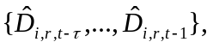 gives the estimated demand of firm in mall during the last periods. Furthermore, 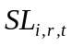 is firm’s current mall stock at the day in period when the stock is checked. Then, standard results from inventory theory suggest that the firm should choose its desired replenishment quantity for region according to the following rule:

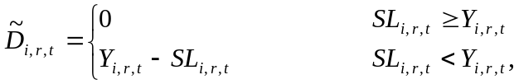

where 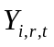 is chosen such that the firm expects to be able to satisfy the market demand with some probability 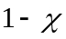. Demand in the current period is estimated using a linear regression based on previous demands. Put formally,
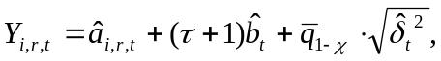

where 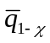is the quantile of the standard normal distribution and the parameters 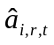 and 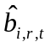 are estimated using standard linear regression methods. Thus, we have
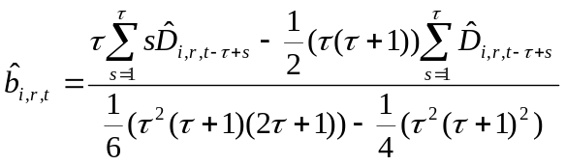 and 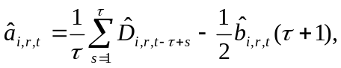
and for the variance
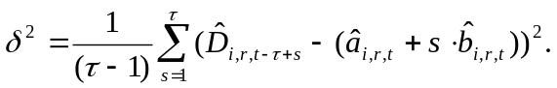

The sum of the orders received by all malls becomes

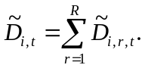

To avoid excessive oscillations of the quantities 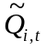 that the firm desires to produce in period , the time-series of total quantities required by the different malls (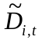) is smoothed. On this account, the consumption goods producer shows some inertia in adapting the actual production quantity to the quantity requested by the malls. In particular, we have

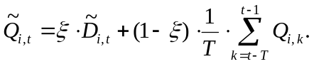
As discussed in more detail below, the realized production volume 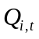 can deviate from the planned output due to rationing on the factor markets. The quantities actually delivered to the malls, 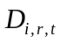, are adjusted proportional to the intended quantities 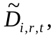 so that
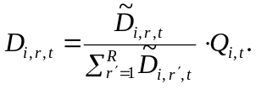

Production times of consumption goods are not explicitly taken into account and the produced quantities are delivered on the same day when production takes place. The local stock levels at the malls are updated accordingly.

  - Factor demand

Consumption good producers, denoted by , need physical capital and labor to produce the consumption goods. The accumulation of physical capital by a consumption good producer follows
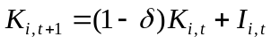

where 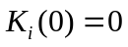 and 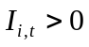 is the gross investment.
Every worker has a level of general skills 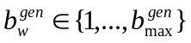 and a level of specific skills 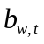. The specific skills of worker indicate how efficiently the corresponding technology is exploited by the individual worker. Building up those specific skills depends on collecting experience by using the technology in the production process. The shape of the evolution of productivity follows a concave curve, the so-called learning curve, when the organizational productivity is recorded after implementing a new production method or introducing a new good. Concavity in this context means that the productivity rises with proceeding use of the production method or production of the new good, but this increase emerges at a decreasing rate. We transfer this pattern of organizational learning on the individual level and assume that the development of individual productivity follows a learning curve. The specific skills are updated once in each production cycle of one month. Further, we assume that updating takes place at the end of the cycle.
A crucial assumption is the positive relationship between the general skills 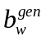 of a worker and his ability to utilize his experiences. Building up worker's technology specific skills depends on a worker's level of general skills, i.e. his education and the other general abilities which are not directly linked to the particular technology. Taking the relevance of the general skill level into account the specific skills of a worker for technology is assumed to evolve according to

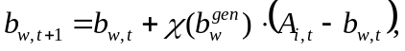

where we denote with 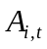 the average quality of the capital stock. The function 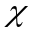 is increasing in the general skill level of the worker. Note that this formulation captures the fact that in the absence of technology improvements marginal learning curve effects per time unit decrease as experience is accumulated and the specific skills of the worker approaches the current technological frontier.
The production technology in the consumption goods sector is represented by a Cobb-Douglas type production function with complementarities between the quality of the investment good and the specific skills of employees for using that type of technology. Factor productivity is determined by the minimum of the average quality of physical capital and the average level of relevant specific skills of the workers. Capital and labor input is substitutable with a constant elasticity and we assume constant returns to scale. Accordingly, output for a consumption goods producer is given by

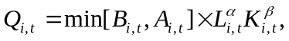
where 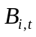 denotes the average specific skill level in firms and 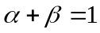.
Firms aim to realize a capital to labor ratio according to the standard rule for CES production functions. That is a ratio of quantity to price of the two factors proportional to the corresponding intensity parameter. Accordingly,

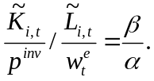

Taking into account the above production function this yields under the assumption of positive investments
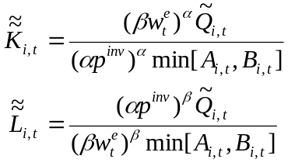

and if 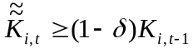 the desired capital and labor stocks read 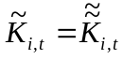 and 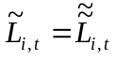. Otherwise, we have
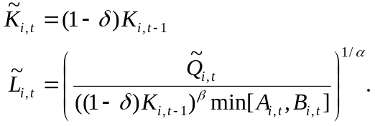

For simplicity credit constraints are not incorporated in this version of the model. All desired investments can be financed.
The monthly realized profit of a consumption goods producer is the difference of sales revenues achieved in the malls during the previous period and costs as well as investments (i.e. labor costs and capital good investments) borne for production in the current period Wages for the full month are paid to all workers at the day when the firm updates its labor force. Investment goods are paid at the day when they are delivered.

  - Pricing

Consumption good producers employ a standard approach from the management literature, the so-called `break-even analysis' to set their prices. The break-even formula determines at what point the change in sales becomes large enough to make a price reduction profitable and at what point the decrease in sales becomes small enough to justify a rise in the price. Basically, this managerial pricing rule corresponds to standard elasticity based pricing.
Assuming that all firms have constant expectations 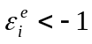 of the elasticity of their demand, they set the price according to the standard rule
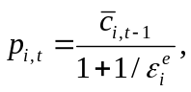
where 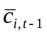 denotes unit costs in production of firm in the previous period. Once the firm has determined the updated prices 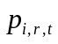 for all regions where it offers its goods, the new prices are sent to the regional malls and posted there for the following period.

3. Households' consumption

Once a month households receive their income. Depending on the available cash, that is the current income from factor markets (i.e. labor income and dividends distributed by capital and consumption goods producers) plus assets carried over from the previous period, the household sets the budget which it will spend for consumption and consequently determines the remaining part which is saved. On a weekly basis, sampling prices at the (regional) mall the consumer decides which goods to buy.

3.1 Selection of consumption goods

At the weekly visit to the mall in his region each consumer collects information about the range of goods provided and about the prices and inventories of the different goods. In the Marketing literature it is standard to describe individual consumption decisions using logit models. These models represent the stochastic influence of factors not explicitly modelled on consumption.We assume that a consumer's decision which good to buy is random, where purchasing probabilities are based on the values he attaches to the different choices he is aware of. Denote by 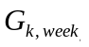 the set of producers whose goods consumer has sampled in week 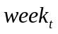 of period and where a positive stock is available at the attended mall. Since in our setup there are no quality differences between consumer goods and we also do not explicitly take account of horizontal product differentiation, choice probabilities depend solely on prices. The value of consumption good 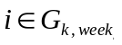 is then simply given by

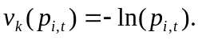

The consumer selects one good , where the selection probability for reads
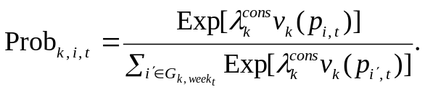

Thus, consumers prefer cheaper products and the intensity of competition in the market is parameterized by 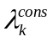. Once the consumer has selected a good he spends his entire budget 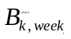 for that good if the stock at the mall is sufficiently large. In case the consumer cannot spend all his budget on the product selected first, he spends as much as possible, removes that product from the list , updates the logit values and selects another product to spend the remaining consumption budget there. If he is rationed again, he spends as much as possible on the second selected product, rolls over the remaining budget to the following week and finishes the visit to the mall.

4. Labor market

4.1 Labor demand

Labor demand is determined in the consumption goods market. If the firms plan to extend the production they post vacancies and corresponding wage offers. The wage offer 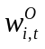 keeps unchanged as long as the firm can fill its vacancies, otherwise the firm updates the wage offer by a parameterized fraction. In case of downsizing the incumbent workforce, the firm dismisses workers with lowest general skill levels first.

  - Labor supply

Job seekers consist of a randomly determined fraction of employed workers who search on-the-job and the unemployed. A worker only takes the posted wage offer into consideration and compares it with his reservation wage 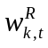. A worker will not apply at a firm that makes a wage offer which is lower than his reservation wage. The level of the reservation wage is determined by the current wage if the worker is employed, and in case of an unemployed by his adjusted past wage. That is an unemployed worker will reduce his reservation wage with the duration of unemployment. When a worker applies he sends information about his general as well as his specific skill level to the firm.

4.3 Matching algorithm

According to the procedures described in the previous sections consumption goods producers review once a month whether to post vacancies for production workers. Job seekers check for vacancies. The matching between vacancies and job seekers works in the following way:

- The firms post vacancies including wage offers where the offered wage depends on the general skill level of the applicant. In particular, each worker is offered a wage consisting of a base wage offer multiplied with the average specific skill level of the firm employees whose general skill level matches that of the applicant.
- Every job seeker extracts from the list of vacancies those postings to which he fits in terms of his reservation wage. Job seekers rank the suitable vacancies. The vacancy which offers the highest wage is ranked on position one and so on. If the wage offers that come with the posting are equal, vacancies are ranked by chance.
- Every firm ranks the applicants. Applicants with higher general skill 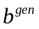 levels are ranked higher. If there are two or more applicants with equal general skill levels, but different specific skill levels, the applicant with the higher specific skill level is ranked higher. Based on their ranking firms send job offers to as many applicants as they have vacancies to fill.
- Each worker ranks the incoming job offers according to the wages net of commuting costs (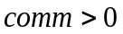) that may arise if he was to accept a job in the region where he does not live. Each worker accepts the highest ranked job offer at the advertised wage rate. After acceptance a worker refuses all other job offers and outstanding applications.
- Vacancies' lists and applications' lists are adjusted for filled jobs. If a firm received refusals, these applicants are dropped from the list of applicants. If all vacancies of a firm have been filled the firm refuses the other applicants and the algorithm for this firm ends.
- If the number of vacancies not filled exceeds some threshold 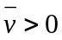 the firm raises the base wage offer by a fraction 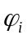 such that 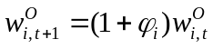. If an unemployed job seeker did not find a job he reduces his reservation wage by a fraction 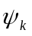, that is (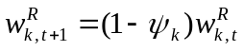). There exists a lower bound to the reservation wage 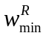 which may be a function of unemployment benefits, opportunities for black market activity or the value of leisure. If a worker finds a job then his new reservation wage is the actual wage, i.e. 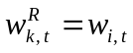. Go to step 1.

This cycle is aborted after two iterations even if not all firms may have satisfied their demand for labor. As indicated above this might lead to rationing of firms on the labor market and therefore to deviations of actual output quantities from the planned quantities. In such a case the quantities delivered by the consumption good producer to the malls it serves is reduced proportionally. This results in lower stock levels and therefore increases the expected planned production quantities in the following period.

